Unit5

一．连线

 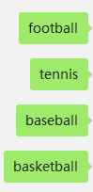

1. Ask and answer.

1.Let’s go to the playground.

1. Let’s go to the zoo. B.Ok,let’s go.

2.Can you climb?

1. Yes,I am. B.Yes,I can.

3.May I play with you?

1. Ok,let’s go. B.Sure.

4.Can you play football?

A.yes,you can. B.Yes,I can.

三．填空；

ootball 足球； ennis网球； an能； lay玩； all球