Unit3

一．连线

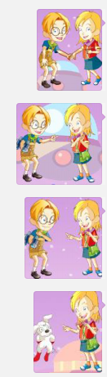 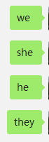

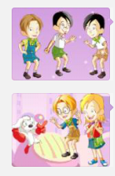 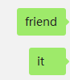

二．填空：

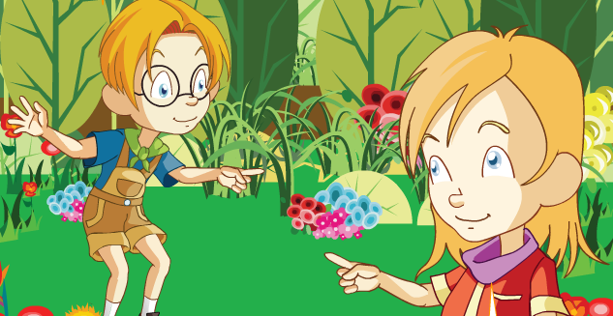

（He/She) is Iris.

（He/She) is Maths.

1. 选择
2. is B. are
3. He my friend.
4. She a girl.
5. We boys.
6. They friends.