反馈画面：表情动作语调 夸张一点

Ya！So smart.

Good job.

You are right.

1. O. Try again.

Very good.

Excellent

Louder

Say again

OO . I can’t hear you.

Wonderful

Repeat after me. Green ， very good.

Say again. yellow. Good job.

Try again. Red. Good job.

Video :

opening：

Yo! kids, we've just learnt some cool stuff!

Let's check how good you are!

Are you ready? ...Go!

场景 1 : (单词场景）

What is？

What color is it？

场景 2: （红绿灯场景）

Which one is blue？

Which one is yellow？

Which one is red？

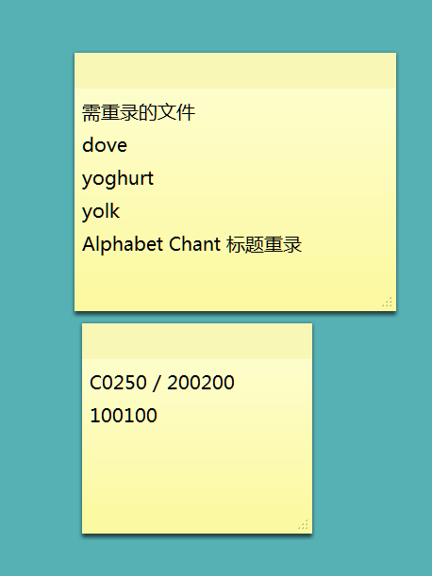

安排周三

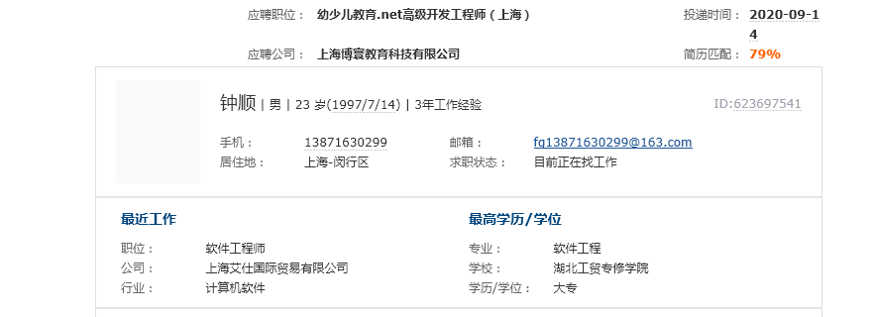

安排周四 下午13:30 已发地址，微信加上了

