1. **Request URL:**

<http://www.51weixiao.net/WeSchool/TeachingCourse/ashx/TeachingCourseHandler.ashx?action=getComment&classId=11689&studentId=1FEE6342-C784-4420-9D24-6260A6880F47>

1. **Request URL:**

<http://www.51weixiao.net/WeSchool/TeachingCourse/ashx/TeachingCourseHandler.ashx?action=getComment&classId=11689&studentId=1FEE6342-C784-4420-9D24-6260A6880F47>

TeachingCourseHandler 【测试跳转的 总方法】 codeHandle（）方法用来request和response

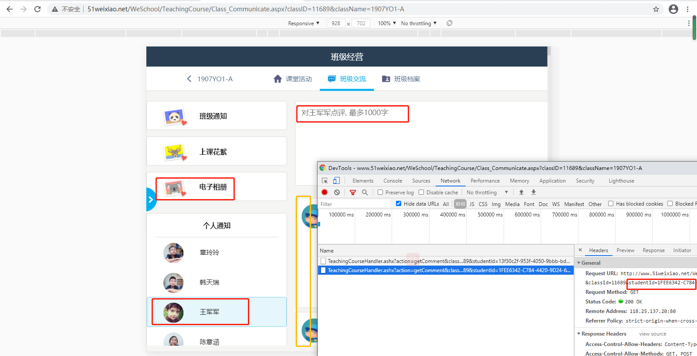

//////

传入 学生id和classid 进行Stringbuilder 拼接点评 最终 返回 response、