Review Sheet (4)

**Unit7~8**

Name:_________________ Class: ___________________ Score: ________________

1. **Spelling 27%**
2. 7 s **eve**n 2. 8 e **igh** t 3. 4 f **ou** r

4.10 t **en** 5. 3 t **hre**e 6. 9 n **in** e

7. b **all**o o **n** 8. d **e s** k 9. cl **ass_**room

1. **Fill in the blanks. 12%**

[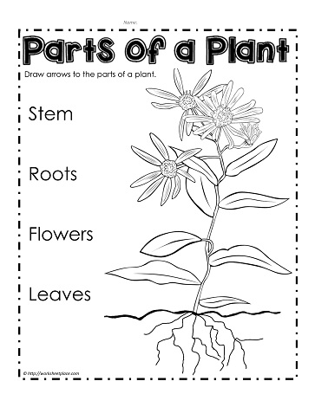](https://worksheetplace.com/mf_pdf/Label-The-Plant-Parts.pdf)

**flower**

**stem**

**root**

**leaf**

**___**

**__**

**______**

**_____ _**

1. **Choose the best answers. 20%**
2. __ What is this?
3. It is a book bag. b. She is Iris.

c. These are desks.

1. __ How many pencils are there?
2. There is a balloon. b. There are 5 pencils.

c. There is 2 pencils.

1. _ _ What are those?
2. There are 4 desks. b. Yes, they are. c. Those are erasers.
3. __ Are these roses?
4. Yes, they are. b. Yes, it is. c. Yes, we are.
5. __ What is that?
6. That is a marker. b. They are markers. c. Yes, it is.
7. ___ How many leaves are there?
8. They are leaves. b. Yes, you are.

c. There are 10 leaves.

1. __ Are those balloons?
2. No, it isn’t. b. Yes, it is. c. Yes, they are.

1. __ Are these flowers?
2. No, they aren’t. b. Yes, they aren’t. c. Yes, it is.
3. __ Is it an eraser?
4. Yes, I am. b. Yes, it is. c. No, it is.

1. __ Are those rulers?
2. Yes, she is. b. Yes, they aren’t. c. Yes, they are.
3. **Abbreviation. 10%**

**EX：I am = I’m**

1. are not = __**aren’t_**___ 3. is not = _**_isn’t_**_____
2. It is = ____**It’s_**____ 4. They are = ___**They’re**_____
3. What is = _**_What’s_**___
4. **Plural Nouns. 20%**

**EX: desk →desks**

1. rose **→ _____** 2. this **→ ______**

2.leaf**→ ______** 4. is **→ _______**

4. he/it/she **→ ________** 5. that **→ _________**

1. **Read the passage. T=True or F=False 10%**

Look! There is a park. There are many flowers and trees. How

many kids are there? There are 8 kids. 5 boys and 3 girls. The boys play

basketball. The girls run in the park. What are they? They are balloons.

How many balloons are there? 1, 2, 3...10. There are 10 balloons.

F□ 1. There is a garden. F□ 2. The boys jump in the park.

T□ 3. There are 10 balloons. F□ 4. There are 3 boys.

T□ 5. There are many trees in the park.